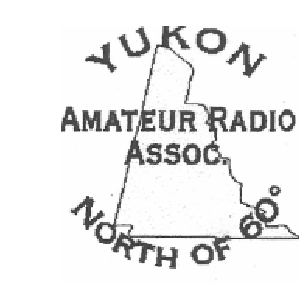
YUKON AMATEUR RADIO ASSOCIATION MEMBERSHIP FORM

NAME:
CALLSIGN:
ADDRESS
P/CODE
PHONE: FAX:
EMAIL:
Please check the following if it applies to you:
Mobile radio ___ Handheld ___ VHF radio
Type of Antenna used
Would you be available for events that YARA provides their services:
Kluane Chilkat Bike Race
International Relay Race
Mock Disasters
Any other events:

